Fun with Shopping

Original software created by Eilia Keyhanee. This software may be freely used, edited, and distributed. (See Terms & Conditions on page 3)

The Software and is available in 3 languages in version 1.0. Translations credited to Google Translate.

Fun with Shopping is a software designed to assist the user with keeping track of items they want to purchase at a store. It provides the user with a list, a count of the items they wish to purchase, the cost of each Item, and the total cost of their shopping trip.

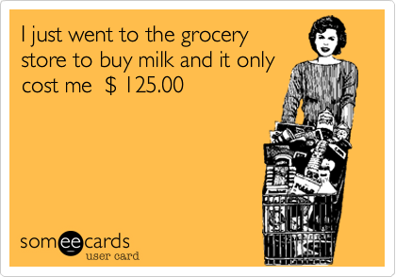

# Contents:

User Interface …………………………………………………………………………………………………………………………. Page 2

Available Items ……………………………………………………………………………………………………………………….. Page 3

Current Items List ……………………………………………………………………………………………………………………. Page 3

Categories ……………..…………………………………………………………………………………………………………….…. Page 4

Removing Items ………………………………………………………………………………………………………………………. Page 4

Total Items & Costs …………………………………………………………………………………………………………………. Page 4

Version Number ……………………………………………………………………………………………………………..………. Page 5

Language Selection …………………………………………………………………………………………………..…………….. Page 5

Terms & Conditions …………………………………………………………………………………………………….....………. Page 6

Contact Details ……………………………………………………………………………………………………………………….. Page 6

# User Interface

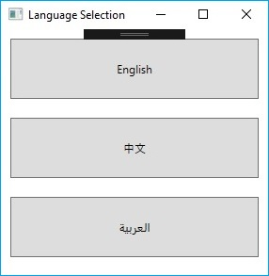

The image the right is an image of the Language Selection window of the program. You will find this window upon starting the program.

You may select the language the rest of the program will be loaded in by clicking on the button with your desired language written on it. See Page 3

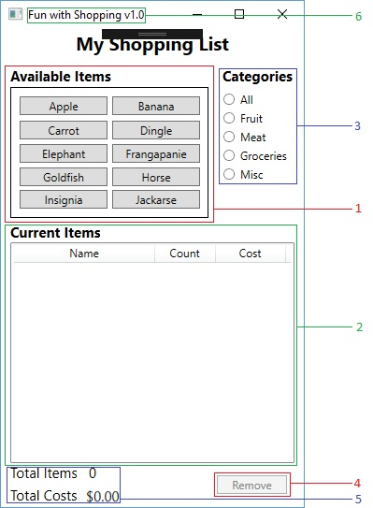

1. These are the Items that are available and ready to be added to the “current” list (2). You may add your desired Items by clicking on the corresponding button. See Page 3
2. This is a list of the items you have currently added to your shopping list. The “Name” column indicates what the item is, the “Count” column indicates how many of that item has been added to the list, and the “Cost” column indicates the combined cost of that item.
3. You may use these radio buttons to disable all items that are not in your selected category.
4. The “Remove” button may only be used when an item is selected on the current list. Upon selecting a previously added item and clicking “Remove” the item will be removed from the list.
5. This text displays the total number of items currently added to the list.
6. This text displays the total cost of all items currently added on the list.
7. This text is the name of the program followed by the version of the program currently being used.

# Available Items:

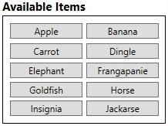On the top left corner of the main window, you will see a box containing 10 buttons.

Each of these buttons can be used to add an item to the “Current Items” list.

By hovering your mouse over the buttons, a tool tip is appears that displays the cost of the item.

The first time an item is clicked, it is added to the list. If a button is clicked again it will only increase the count and cost of the previously added item. Like so:

# Current Items List:

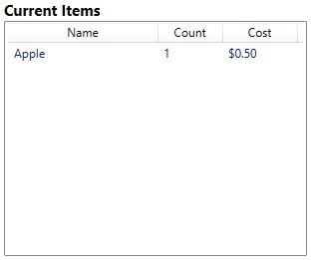

As you can see, the apple was added to the list when the “Apple” button was clicked.

The “Name” column displays the name of the item that was just added. The “Count” column displays the number of times the corresponding item was added, and finally, the “Cost “ column displays the total cost of all items of that type that were added.’

Now, if the user adds another item to the list, the following will happen:

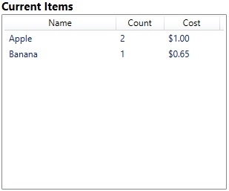

As you can see, a separate item has been added to represent the banana. The banana has a separate count, and total item cost.

However, when another apple is added, there is no separate item added to the list. Instead, the same item has been kept. Rather than adding a separate item, the count and cost have gone up. The cost of the apples has gone from $0.50 to $1.00 and the count has gone to 2 from 1.

# Categories:

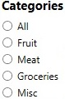The image on the left is a snapshot of the categories section of the software. The section can be located on the top left side of the main window in the software. You may use the radio buttons located in the section to disable any buttons that are not of that category in the “Available Items” section (Page 3). For example, selecting the “Fruit" category would grey out or disable all non-fruit buttons (Only Apple, Banana, and Carrot are in the Fruit Category.

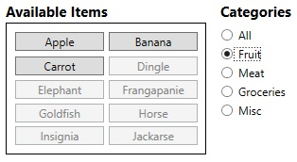

This function is demonstrated here:

Selecting the meat category would disable all buttons but Dingle and Elephant, Groceries would disable all but groceries etc.

# C:\Users\eilia\AppData\Local\Microsoft\Windows\INetCache\Content.Word\Remove1.jpgRemoving Items:

If you have added too many items, or have changed your mind on what items you would like to have on your list, you may remove them by selecting the item you wish to exterminate and clicking the “Remove” button, located on the lower right corner of the main window of the program.

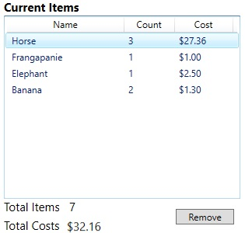The “Remove” button will only be enabled when an item is selected. If there is more than one of the item in the list, rather than the item being removed, the count and cost will simply go down. The process of removing items is demonstrated here:

# Total Items & Costs:

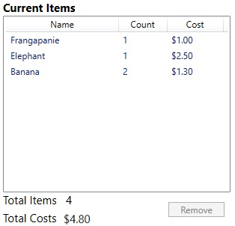This text at the bottom left corner of the main window displays the total number of items on the list, as well as the total costs of all items on the list combined

If you bring your attention to the bottom right corner of the images on the side, you will notice the “Total Items” decreasing by 3 as the 3 “Horse” Items are removed, as well as the “Total Costs” decreasing by $27.36.

# Version number:

C:\Users\eilia\AppData\Local\Microsoft\Windows\INetCache\Content.Word\Version.jpg

Draw your attention to the header of the main window, you can see the title and version of the certain variant of the software you are using. This manual was created for Fun with Shopping v1.0 (the original software).

# Language Selection:

Upon starting the program. You will find a language selection window. Selecting a Language is simple. Click the button with the name of your desired language written on it ( the names are written in the appropriate language).

Fun with shopping supports English, Chinese (simplified) and Arabic. All features are available and work the same way in all languages. Translations credited to Google Translate.

To report any incorrect or inaccurate translations, or bugs involving the Arabic or Chinese versions of the program, please email the developer with the subject “Fun with Shopping Language issue”. (Email provided at the end of User Manual).

The following are the two alternative language variants of the software:

## C:\Users\eilia\AppData\Local\Microsoft\Windows\INetCache\Content.Word\Arabic.jpgC:\Users\eilia\AppData\Local\Microsoft\Windows\INetCache\Content.Word\Chinese.jpg

# Terms & Conditions:

1. All edited versions of this program must credit Eilia Keyhanee as the original developer of the software.
2. All edited versions of this program must include the Original Terms & Conditions of Fun with Shopping v1.0.
3. This software and any other software based on this one cannot be sold or traded.
4. This software cannot be distributed through free software distribution sites.
5. This software cannot be distributed through offline storage (USB devices etc.)
6. This software may not be opened by anyone. Excluding Nicholas Dingle and Eilia Keyhanee
7. By opening this document, you are hereby forfeiting your right to freedom of movement, freedom of conscience, and freedom of speech. You do this knowingly and freely.
8. Fun with Shopping must not be used to assist in shopping endeavours.
9. This document must not be read.
10. Thou shall not murder.

# Contact Details:

For any questions or inquiries, please contact customer support at:

[Eilia.keyhanee1@education.nsw.gov.au](mailto:Eilia.keyhanee1@education.nsw.gov.au)

Our inbox is frequently checked for customer feedback roughly once every 4 months.